**Website Rendition 1**

[**https://omnia-grow.netlify.com/**](https://omnia-grow.netlify.com/)

**11.23.19**

**Agriculture Technology or Agricultural Technology?**

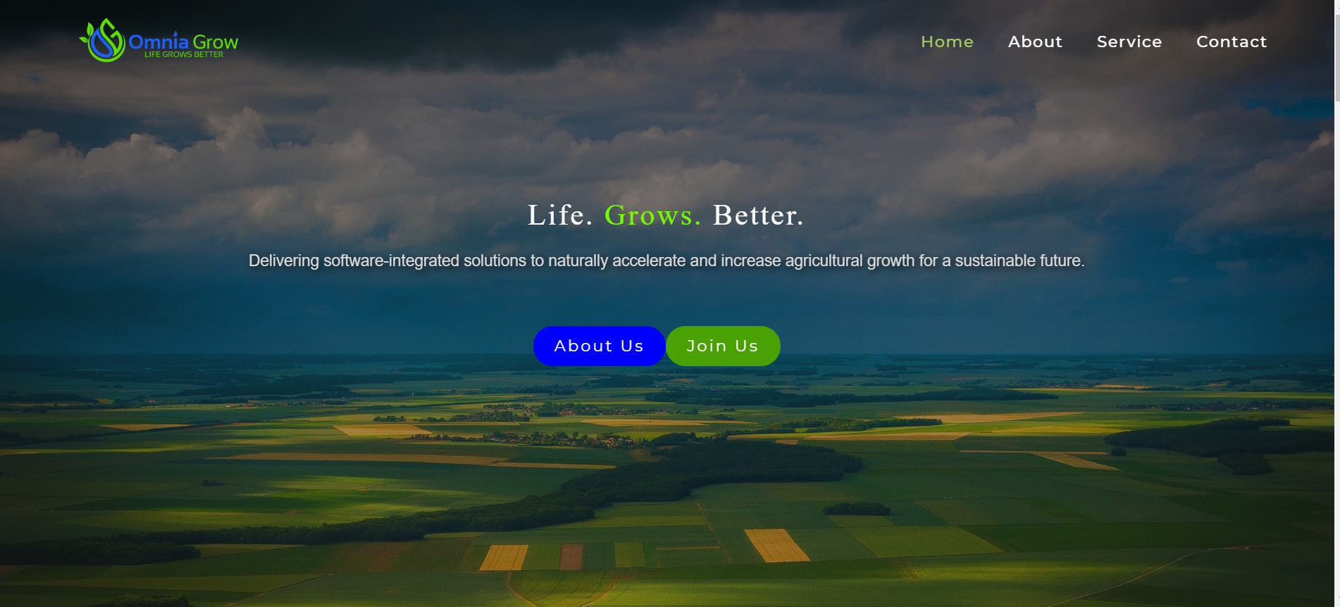

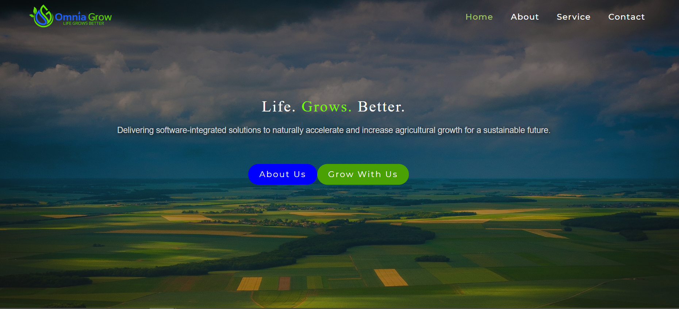

**Changes:**

1. Please make Logo in top left corner Larger, large enough to read “Life Grows Better”
2. Life Grows Better (No periods after) – Text larger as well – Like the idea of “Grows” being green
3. Update text: “Agricultural Technology effectively accelerating growth and increasing yields for a Sustainable Future”
4. I do like update of Buttons mirroring the logo, please reduce size of buttons however slightly
   1. Also please add the white boarder like the initial (would like to see how this compares)
   2. When hovering over 2 icons “About Us” and “Grow With Us” – right now it turns to black, possible to change to other color? For blue to change to green and vice-versa, or turn white – Something other than Black
5. Also change text from “Join Us” to “Grow With Us”
6. Have all 4 at top (Home, About Service Contact) be White and then when hover over change to Green
7. Please send me this photo file so I can forward to Douglas, he is going to edit the clouds and photograph

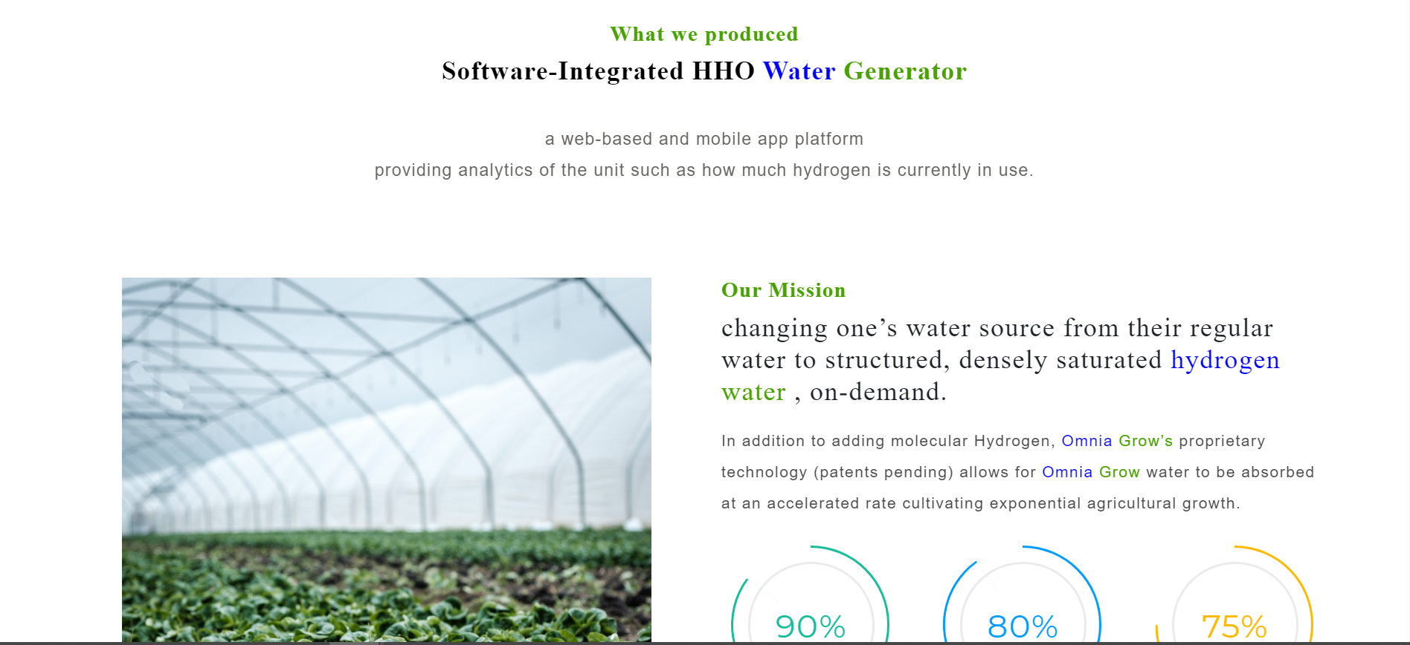

**INSERT:** Under updated text and above photo of greenhouse with lettuce

**\*\*\*Hydrogen Oxygen Water System Product Launch 2020\*\*\***

**Changes:**

1. Update What we Produced to -> “How Life Grows Better”
2. Update “Software-integrated…” -> “Hydrogen Oxygen Water System with Software Integration”
3. Updated “a web-based….” -> “HHO Water System distributing on-demand hydrogen and oxygen-infused water cultivating faster, healthier, more abundant growth

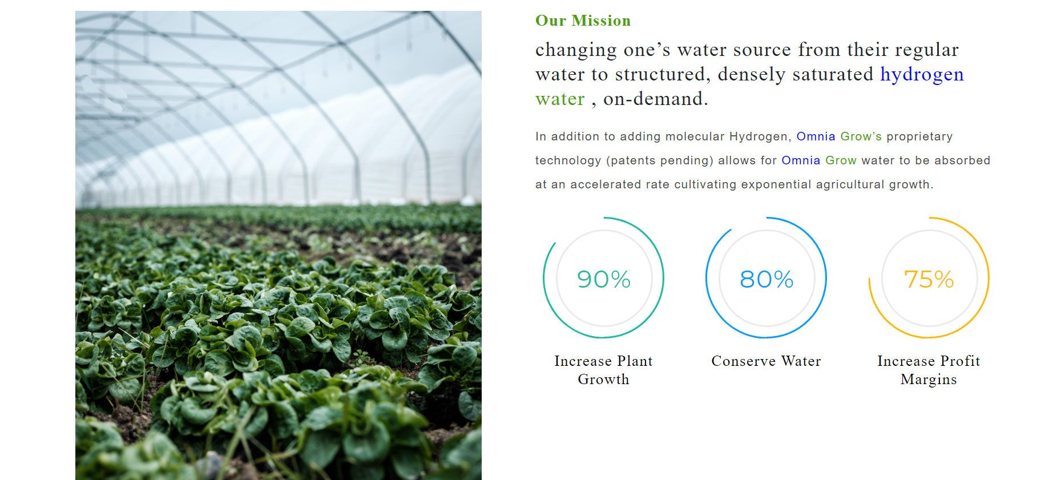

**Changes:**

1. **Our Mission** -> “Providing innovative agricultural technologies designed to cultivate accelerated growth, increase yields and overall agricultural potential. Sustainable solutions, helping with Economic Development through Agricultural Development.”
2. **How This is Accomplished ->** “By changing one’s water, either at the source or through irrigation, to structured, densely saturated Hydrogen Oxygen Water, on-demand.”
   1. “In addition to adding molecular Hydrogen & Oxygen, Omnia Grow’s proprietary technology allows for Omnia Grow’s HHO Water to be absorbed at an accelerated rate, further cultivating exponential agricultural growth”

**OUR MISSION ICONS**

1. Plant Growth (Dark Green) (75%)
2. Conserve Water (Omnia Grow Blue) (45%) decrease in water usage
3. Increase Profit Margins (Omnia Grow Green) (70%)

_____________________________________________________________________________________

**MAJOR CHANGE** (as discussed in office)-> Shifting Services Down and Omnia Grow Features Up

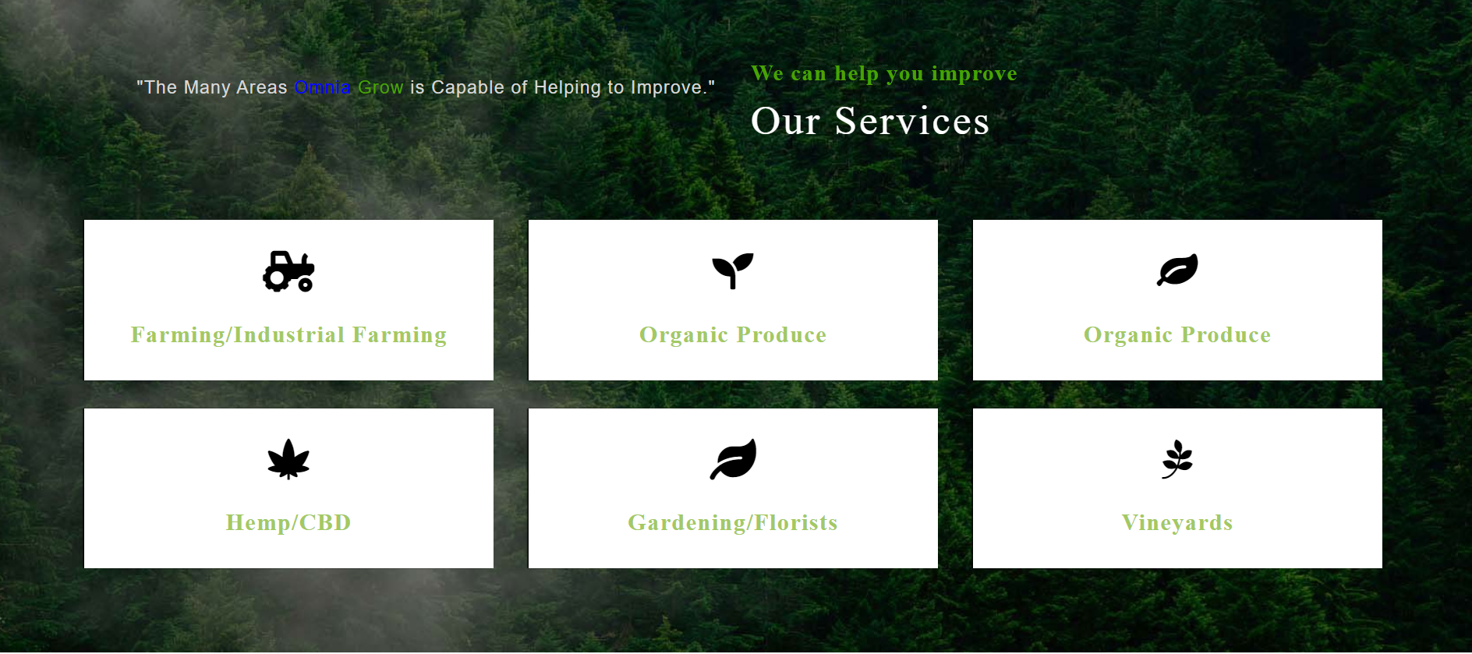

**Change:**

1. “Our Services” -> **“The Markets We Serve”**
2. “The Many Areas Omnia Grow is Capable of Improving Cultivation”
3. Icons
   * Farming/Industrial Farming – Keep tractor
   * Organic Produce -> one green icon – keep top center
   * Industrial Hemp/CBD – Keep Leaf
   * Gardening/Florists – Change to Flower
   * Aquaponics/Hydroponics – Water drop symbol
   * Vineyards/Wineries – Keep vine

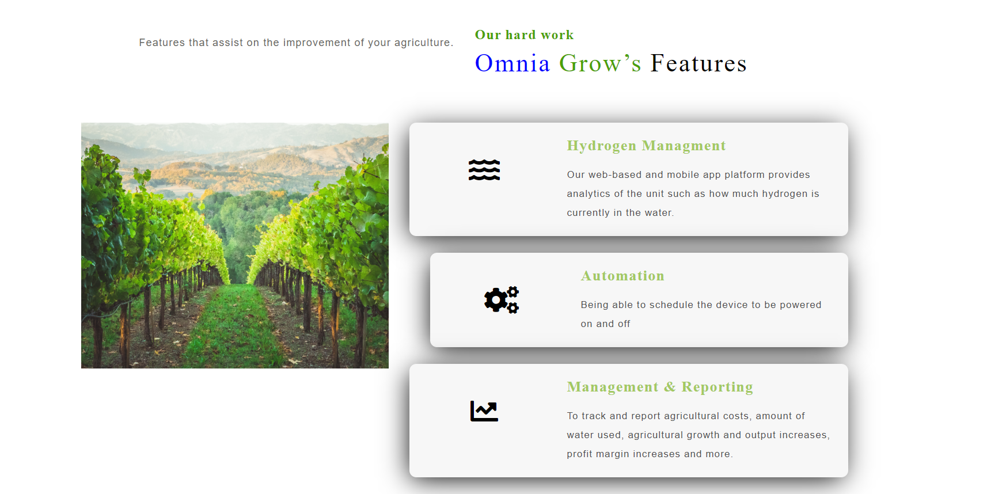Now located above “Markets We Serve”

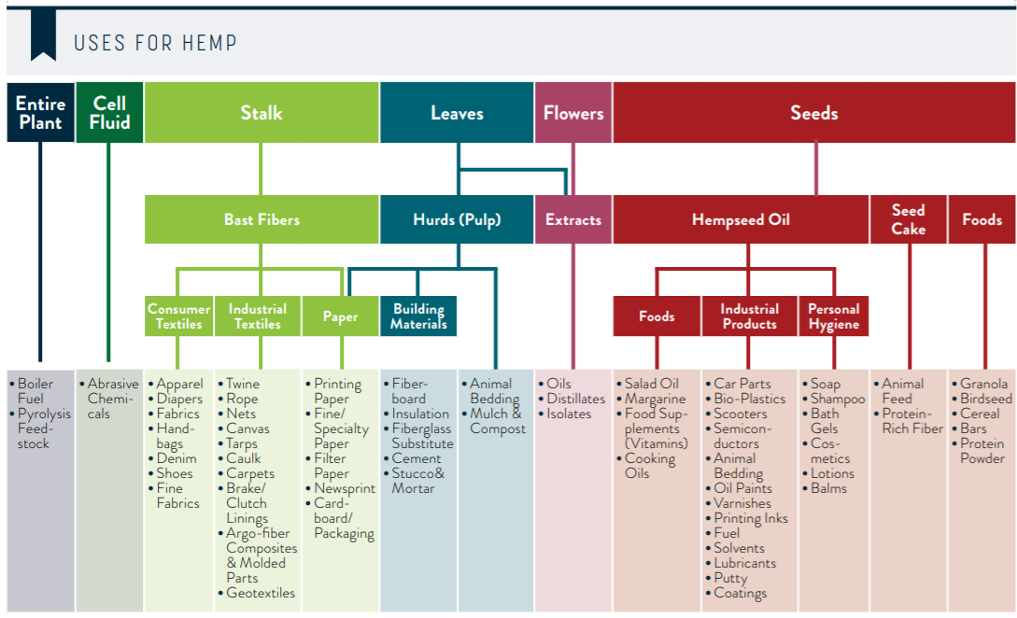**Possible “Modul” where hover over hemp plant and see many uses? -> if not please locate underneath or when you click hemp plant**

**\*Hemp Business Journal-New Frontier Data, The Global State of Hemp 2019 Industry Outlook**

**Changes:**

1. Photo -> **Back to Hemp Plant** 
   1. with this breakout of “Uses For Hemp” Hemp products Underneath Photo or as “Modul”
2. Underneath “Our Hard Work”
   1. “Streamlining with Technology & Automation”
3. -> “System features assisting with the improvement of your agriculture”
4. **Hydrogen & Oxygen Management** – “Our web-based and mobile app platform provides analytics of the unit such as how much hydrogen is currently in the water.”
5. **Automation** – “Being able to configure the device to be powered on and off on around the schedule of your choosing. Adjust for seasonal needs. Adjust for Indoor or outdoor cultivation.”
6. **Analytics & Reporting** – “To track and report agricultural costs, amount of water used, agricultural growth and output increases, profit margin increases and more.”

**FEEDBACK**

* Love the look and feel/UI experience so far (may suggest changing from sliding down the page to going to another page, no need as of now)
* Really like the photographs used
* Mobile and laptop/desktop view is very nice layout
* Straight Forward, professional, clean look – Douglas/Joshua agree

**UPDATES/CHANGES MADE**

* Color scheme to be updated to Omnia Grow colors once receive the color codes from daphne
* % increase icons – click and takes you to article and/or information (Soon to be Omnia Grow Research Studies with Water)
* Vineyard shot instead of Forest – Keep hemp plant photo where it was but replace forest with shot of vineyard and hills or something of the right size that fits please
* Omnia Blue on module – “Services” – Gradient possibility from white to Omnia Grow Blue when click on the button and takes to information
* All Boxes the same size